# HORTICULTURE DATASET FINAL REPORT

## **What is Horticulture? A Modern Applied Plant Science!**

Horticulture is the science and art of the development, sustainable production, marketing and use of high-value, intensively cultivated food and ornamental plants.

Horticultural crops are diverse, including:

* Annual and perennial species,
* Fruits and vegetables,
* Decorative indoor plants and
* Landscape plants.

Horticulture also contributes to quality of life, and the beauty, sustainability and rehabilitation of our environment and the human condition.

Plants, crops and green spaces sustain and enrich our lives by providing nutritious food, enhancing the beauty of our homes and communities and reducing our carbon footprint.

## What does a horticulturist do?

A Horticulturist is responsible for increasing yield, improving vigor, size, and taste of plants. They also coordinate research programs for selective crops. Horticulturists must have extensive knowledge about trees, flowers, vegetables, nuts, bushes, and fruits.

## Horticulture Data Visualization Report :

**Overview of Report :**

This visualization report contain the data of all over india where the plants of spices grow which is called Hoticulture. Accourding to dataset report there are top 15 state's in india where the mostly this farming is done.

Main thing which is focus on project is How much and Where the plant prondution is done more. Acoourding to that data visualization dashboard are created using filters and calculations. Because of this report it will help to analyse area where the prodution of spices is more and also help to focus on this area where the prodution is least.

Beacuse of characterizatio it will help to analysis very well.In this dataset statet's are divided into district's and accourding to the report it will help to analyse particular district's.

**Data Visualization report datails :**

**1. Top 10 Statewise data count**

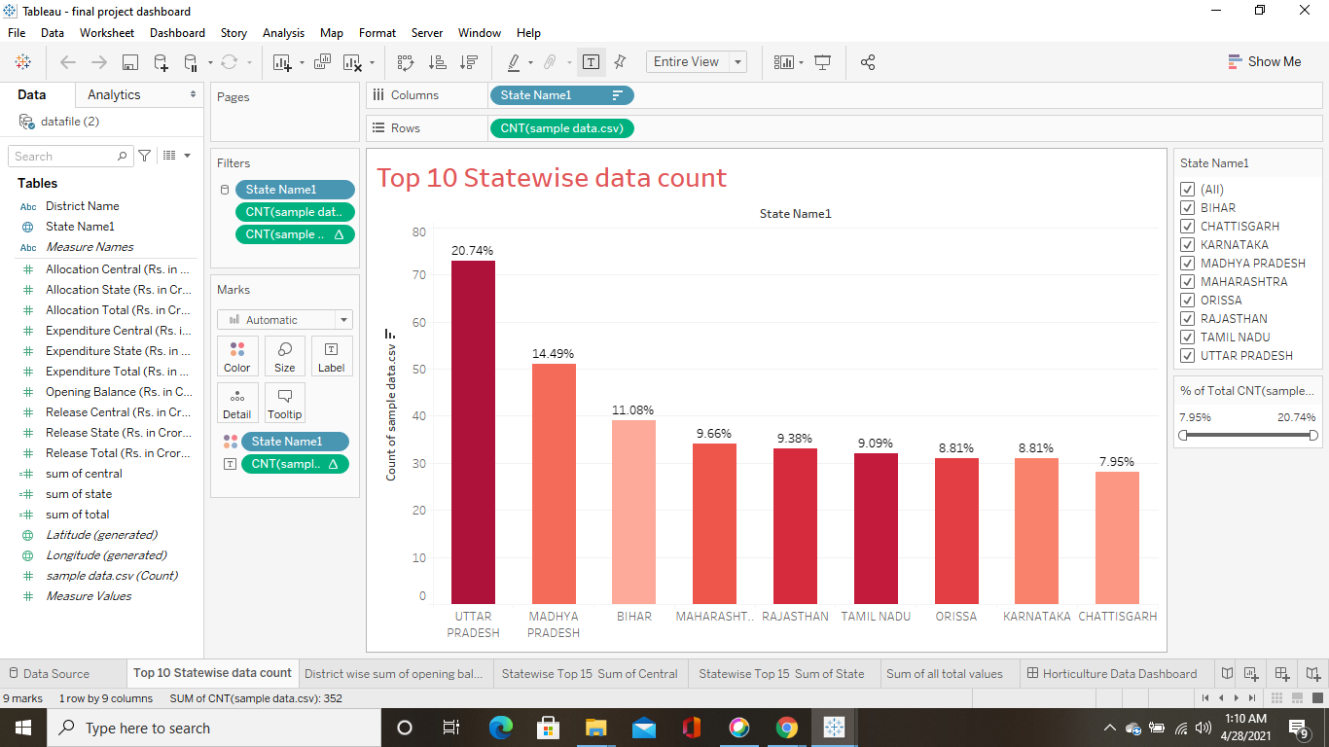

**Operation Performed :**

1. Count of sample data.csv for each State Name1.
2. Color shows details about State Name1.
3. The marks are labeled by % of Total Count of sample data.csv.
4. The view is filtered on State Name1, count of sample data.csv and % of Total Count of sample data.csv.
5. The State Name1 filter keeps 9 of 35 members.
6. The count of sample data.csv filter ranges from 2 to 73.
7. The % of Total Count of sample data.csv filter includes everything.

This is top statewise data count value graph top state is Uttar Pradesh and data count is 20.74%.

**2. District wise sum of opening balance**

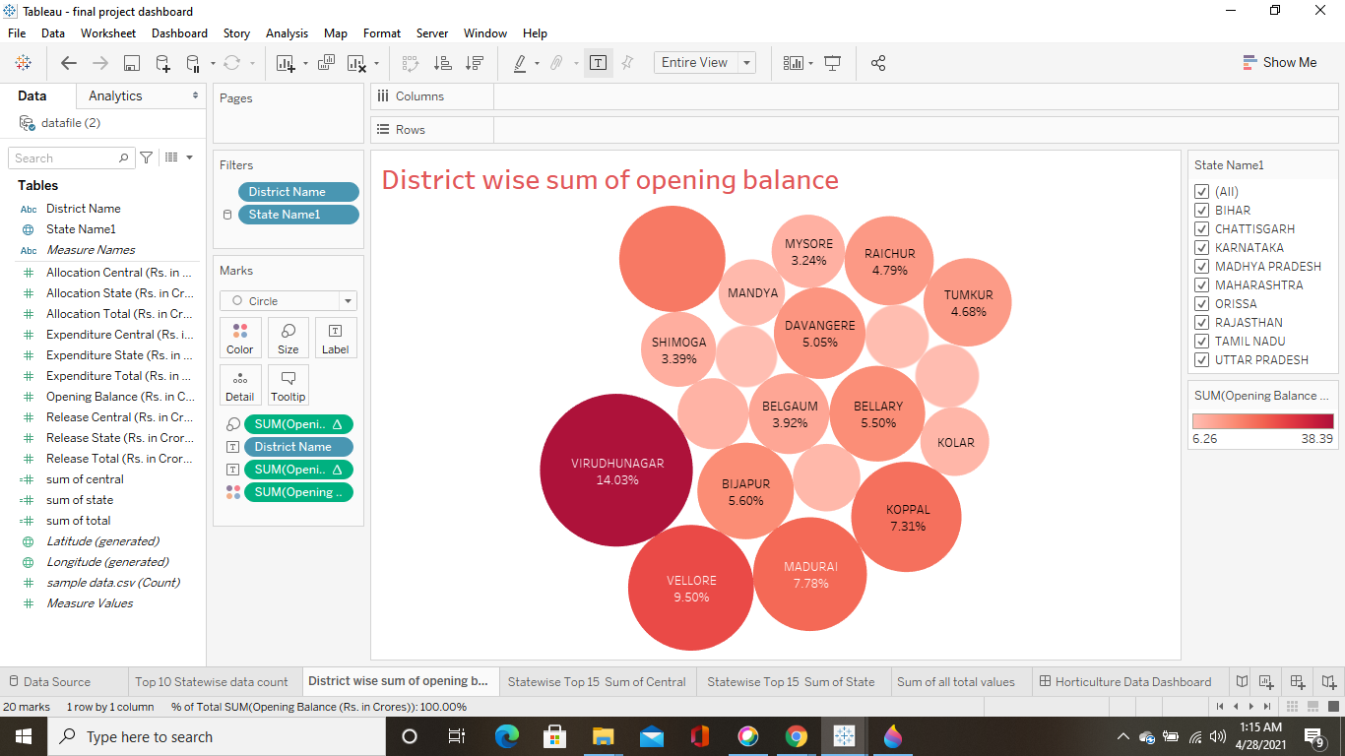

**Operation Performed :**

1. District Name and % of Total Opening Balance (Rs. in Crores).
2. Color shows sum of Opening Balance
3. (Rs. in Crores). Size shows % of Total Opening Balance (Rs. in Crores).
4. The marks are labeled by District Name and % of Total Opening Balance (Rs. in Crores).
5. The data is filtered on State Name1, which keeps 9 of 35 members.
6. The view is filtered on District Name, which keeps 20 of 679 members.

This is arrenged in district wise it contain sum of opening balance data in form of % top 15 district it contains accourding to requirements.

**3. Statewise Top 15 Sum of Central**

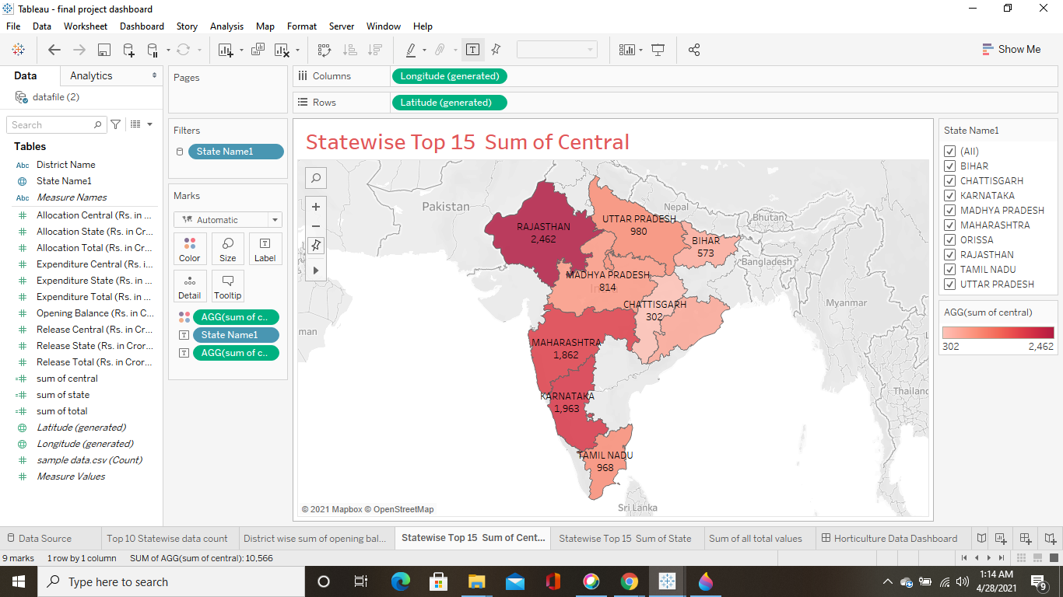

**Operation Performed :**

1. Map based on Longitude (generated) and Latitude (generated).
2. Color shows sum of central.
3. The marks are labeled by State Name1 and sum of central.
4. The view is filtered on State Name1, which keeps 9 of 35 members.

This is top 15 statewise central data which contain sum of all central data and allcoate according filters which is applied.

**4. Statewise Top 15 Sum of State**

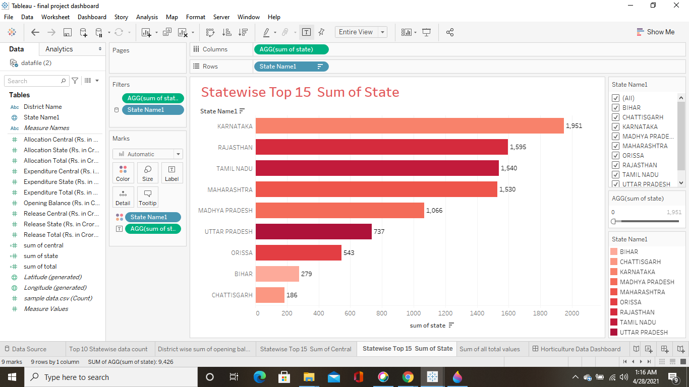

**Operation Performed :**

1. Sum of state for each State Name1.
2. Color shows details about State Name1.
3. The marks are labeled by sum of state.
4. The view is filtered on sum of state and State Name1.
5. The sum of state filter includes values greater than or equal to 0.
6. The State Name1 filter keeps 9 of 35 members.

This is top 15 statewise data which contain sum of all state data and allcoate according filters which is applied.

**5. Sum of all total values**

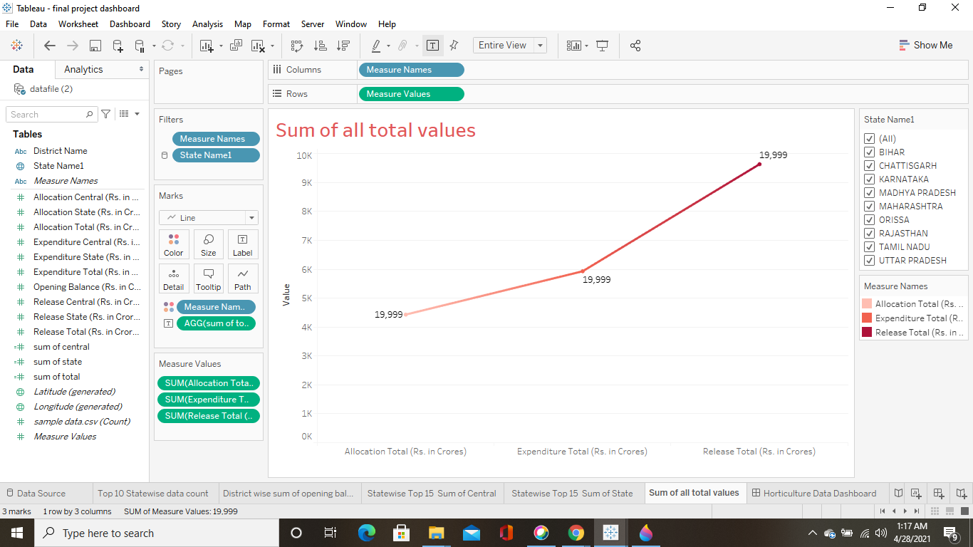

**Operation Performed :**

1. Allocation Total (Rs. in Crores), Expenditure Total (Rs. in Crores) and Release Total (Rs.in Crores).
2. Color shows details about Allocation Total (Rs. in Crores), Expenditure Total(Rs. in Crores) and Release Total (Rs. in Crores).
3. The marks are labeled by sum of total.
4. The data is filtered on State Name1, which keeps 9 of 35 members.

This contain top 15 state and this data is sum of all tatal values which display in form of graphical data.

**Data Visualization report Conclusion :**

This is an dashboard which contain all the sheet data representation it will help to understand all the data at one place.

This data contain's multiple types of data values like,

* Area which is used to grow plants it is divided into two parts central and state.
* Production of plants it is divided into two parts central and state.
* Productivity of grow plants it is divided into two parts central and state.
* Also give total sum of central and state wise data.
* All the values give accourding the year based from2008-09,2009-10,2010-11.

Accourding to final report top 10 state's where the production is more we can also help them to increase the productivity using latest technology and method also based on analysis we will help them to produce this plants or spices whoes productivity is least on this areas.

Also based on analysis the area where the production is least tring to increase the production.

Also using this report based on prodution and productivity values help into horticulture but also in bisuness.

This is link of Horticulture final dataset visualization dashboard link...

[final project dashboard - Pradnya Magade | Tableau Public](https://public.tableau.com/profile/pradnya.magade#!/vizhome/finalprojectdashboard_16195212034210/HorticultureDataDashboard)https://public.tableau.com/profile/pradnya.magade#!/vizhome/finalprojectdashboard_16195212034210/HorticultureDataDashboard